27.2: Need a force from the magnetic field to balance the downward gravitational force. Its magnitude is:
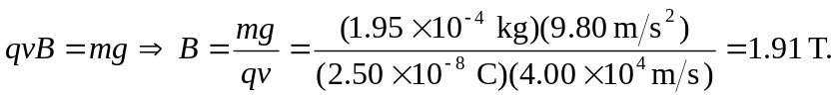
The right-hand rule requires the magnetic field to be to the east, since the velocity is northward, the charge is negative, and the force is upwards.

